Simulation Exercise 1

Automation MIE080

Johan Kellerth Fredlund – [elt11jke@student.lu.se](mailto:elt11jke@student.lu.se)

Koshin Aliabase – [mat09kal@student.lu.se](mailto:mat09kal@student.lu.se)

**Markov chains**

**2.1**

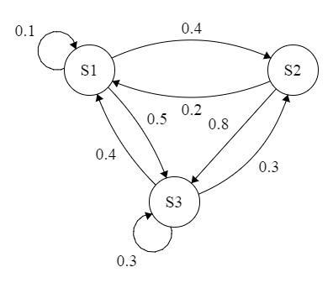

All states are communicating

**2.2**

Eigenvalues: [1 -0.3-0.1414i -0.3+0.1414i]

Yes, it is ergodic. One eigenvalue is one and the rest reaching same stationary values from any initial state. As can be seen in the state graph there are no absorbing states, every state is irreducible. That and the eigenvalues proves that the chain is ergodic.

**2.3**

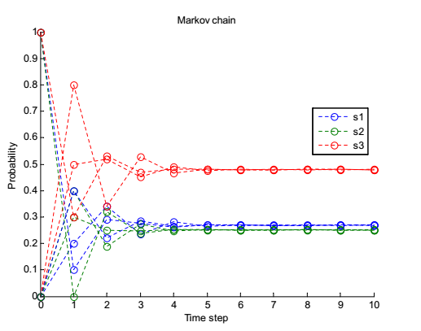

Regardless which state is the initial state the chain will coverge to the same stationary value.

**2.4-2.7**

From textbook:

**6.3d**

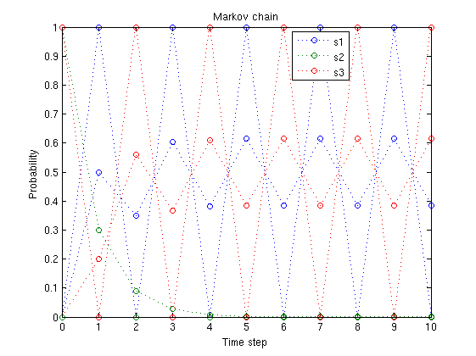

The chain is periodic and will never converge to any stationary values but will shift between state 1 and 3. Not ergodic, periodic and does not reach stationary values.

Ergodic: Absorbing state and reaching same stationary values from any initial state.

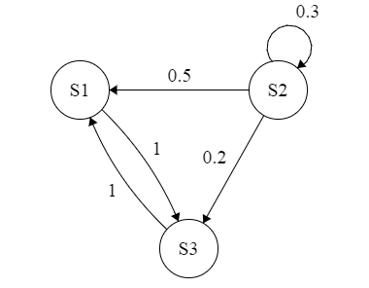

Obvious that it will shift between state 1 and 3 once it reaches either state. It will never stay in either S1 or S3.



Eigenvalues: [0.3 1 -1]

The eigenvalue at -1 means that it will be periodic. An eigenvalue at 1 means that it is a transition matrix. P raised to a large value shows that each row is different, indicating non ergodicity.

**6.3e**

Not ergodic since all states are not communicating. You can see it from the graph as S1 goes to 1 while S2 and S4 does not go to 0.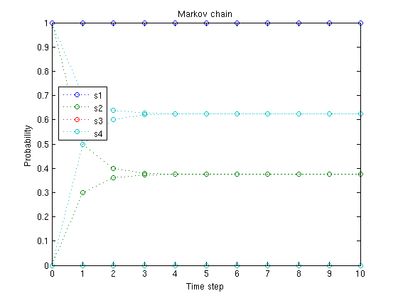

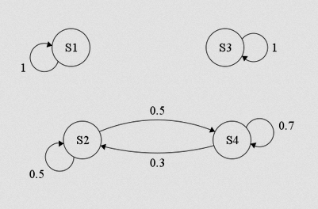

We can see that we have 3 different blocks that are not communicating.

Eigenvalues: [1 0.2 1 1]

Three eigenvalues are 1 which gives not ergodic. P to the power of 100 indicates that each row is unique => non ergodic.

**6.3f**

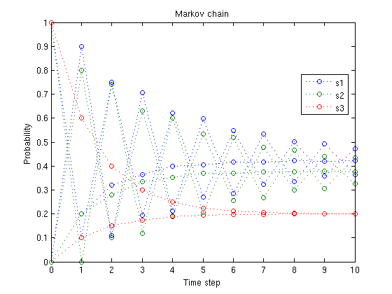

The chain will eventually converge to a stationary value regardless of the initial state as can be seen in the graph as each state comes closer to a stationary values.

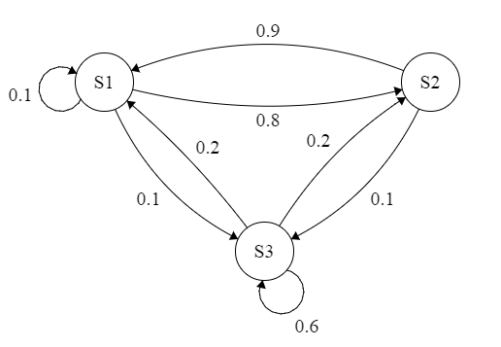

Each state is irreducible, non periodic and therefore ergodic.

Eigenvalues: [-0.8 1 0.5]. P to the power of 100 gives us a matrix with identical row vectors, indicating ergodicity.

**6.3g**

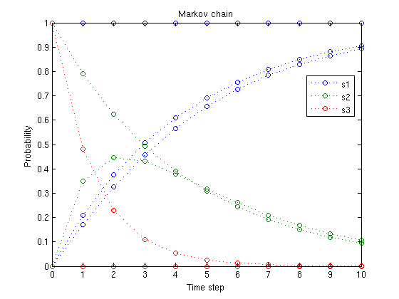

State 1 is an absorbing state and the stationary value will always be [1 0 0]. You can see that in the graph, hence ergodic.

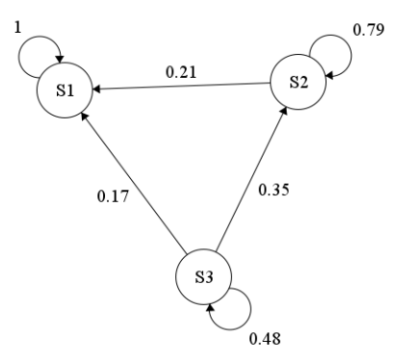

S1 is absorbing, when time goes to infinity we will always end up in S1.

Eigenvalues: [0.48 0.79 1]

When P is raised to 100 we get indentical row vectors, indicating ergodicity.

**2.8**

P does not converge to any stationary value, but is periodic. It is also not ergodic since P raised to 100 does not give us identical rows.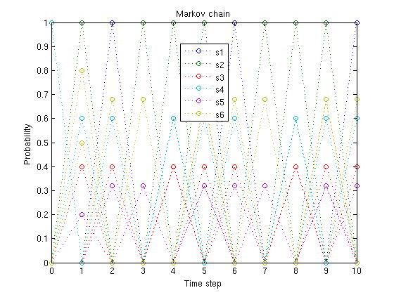

**2.9**

The function never stays in one state, as there is 0 chance that it will stay in S1-6 once it is there, this indicates periodicity.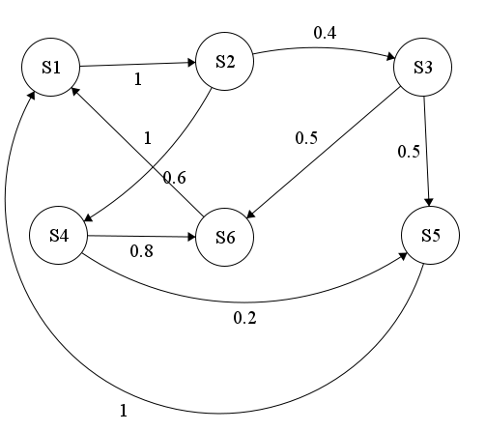

**Markov Process simulation**

**3.1**

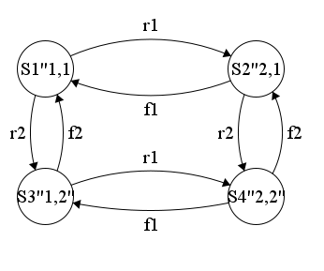

**3.2**

**(1)** r1 =0.2; r2=0.25 f1=0.15; f2=0.1 P1= [1 0 0 0] and P2 = [0 0 1 0]

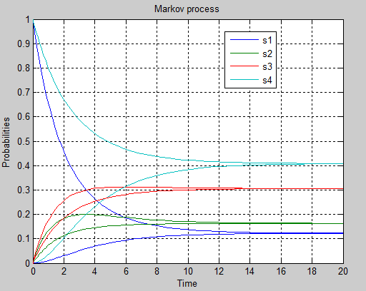

**(2)** r1= 0.4; r2 =0.5; f1= 0.15; f2=0.1 P1 = [1 0 0 0] p2 = [0 0 1 0]

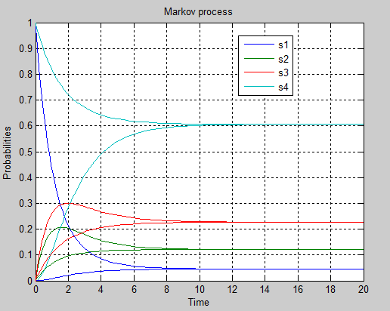

**3.3**

Yes the process is ergodic, stationary values and eigenvalues are in the left half plane

**(1)**

stationary_solution_vector = [0.1224 0.1633 0.3061 0.4082)

Eigenvalues_of_A = [-0.7000 -0.3500 -0.0000 -0.3500)

**(2)**

Stationary_solution_vector = [0.0455 0.1212 0.2273 0.6061]

Eigenvalues_of_A = [-1.1500 -0.0000 -0.5500 -0.6000]

**3.4**

Stationary solution vector = [0.1224 0.1633 0.3061 0.4082]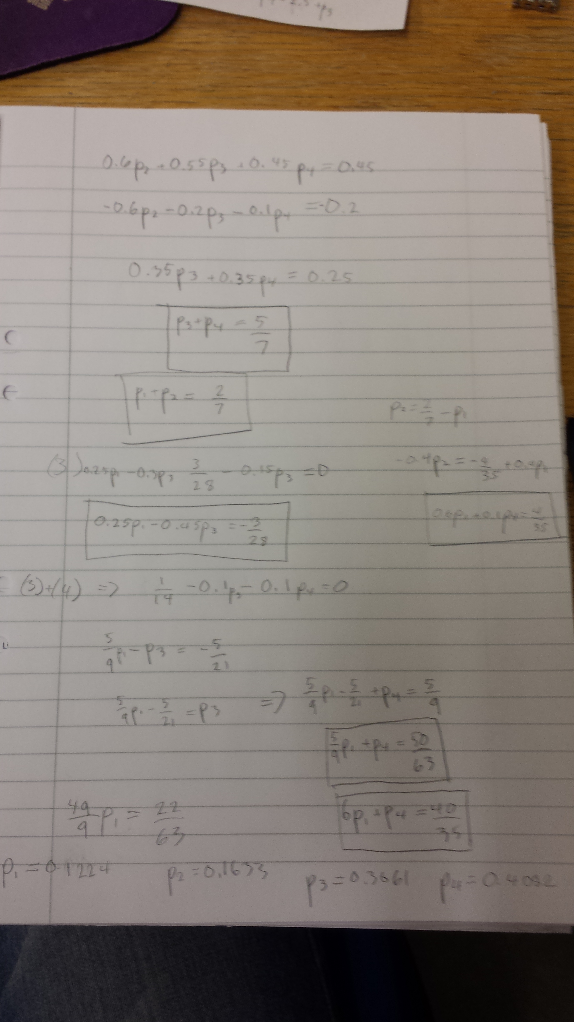

Same as matlab.

**3.5**

**(1)**

Sum (0.1224 0.1633 0.3061 0.4082) =1, Checked.

**(2)**

Sum (0.0455 0.1212 0.2273 0.6061) =1, Checked.

**3.6**

**(1)**

Eigenvalues_of_A = [-0.7000 -0.3500 -0.0000 -0.3500)

We see that all the eigenvalues are in the left half plane which gives us an stable system, converges to stationary values (Not 0 since we have an eig that is 0).

**(2)**

Eigenvalues_of_A = [-1.1500 -0.0000 -0.5500 -0.6000]

Since the system is continuous and all eigenvalues are in the left half plane therefor we can conclude that the system is stable.

**3.7**

We have eight states, one can calculate with the formula 2*2*(N+1) where N is the maximum number of items that the buffer can contain

**3.8**

-0.2500 0.1500 0.1000 0 0 0 0 0

0.1200 -0.2200 0 0.1000 0 0 0 0

0.0700 0 -0.72 0.1500 0 0 0.5000 0

0 0.0700 0.1200 -0.6900 0 0 0 0.5

0 0 0 0 -0.2500 0.1500 0.1000 0

0 0.7000 0 0 0.1200 -0.92 0 0.15

0 0 0 0 0.0700 0 -0.2200 0.15

0 0 0 0.7000 0 0.0700 0.1200 -0.89

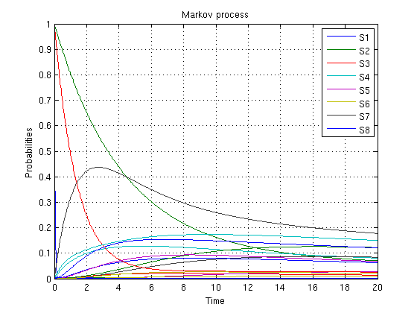

With initial values [0 0 0 1 0 0 0 0].

|  |  |  |  |
| --- | --- | --- | --- |
| State | Buffer | M1 | M2 |
| S000 | 0 | 0 | 0 |
| S001 | 0 | 0 | 1 |
| S010 | 0 | 1 | 0 |
| S011 | 0 | 1 | 1 |
| S100 | 1 | 0 | 0 |
| S110 | 1 | 0 | 1 |
| S111 | 1 | 1 | 1 |

**3.9**

we see from the graph that s7 is the most probable state with the probability 17% , where machine 1 is blocked and machine is under repair because the buffer is full.

**3.10**

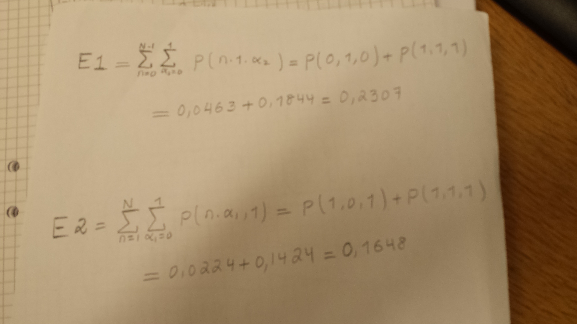

**3.11**

M2 is starved when the buffer is empty with the probability below;

P(M2 starved) = p(0 0 1) +P(0 1 1) = 0.2064+0.1844 =0.3908

**3.12**

M1 is blocked when the buffer is full with the probability below;

P(M1 blocked) = P(1 1 0) + P(1 1 1) = 0.2151 + 0.1424 = 0.3575